**Important links**

<https://login.qt.io/login>

[**https://www.qt.io/download-open-source**](https://www.qt.io/download-open-source)

[**https://docs.qgroundcontrol.com/Stable_V4.4/en/qgc-dev-guide/getting_started/**](https://docs.qgroundcontrol.com/Stable_V4.4/en/qgc-dev-guide/getting_started/)

**https://github.com/mavlink/qgroundcontrol**

**QT and q-ground control installation**

1. **Create qt open source account**

* Go to <https://login.qt.io/login>
* Create a new opensource account by entering email and password
* You will receive email with a link to verify. Click on that link, provide details and it will automatically redirect you to qt open source portal
* In qt opensource portal [Open Source Development | Open Source License | Qt](https://www.qt.io/download-open-source) click on  [**https://www.qt.io/download-open-source**](https://www.qt.io/download-open-source) and AVOID CLICKING “GET YOUR FREE TRIAL NOW BUTTON

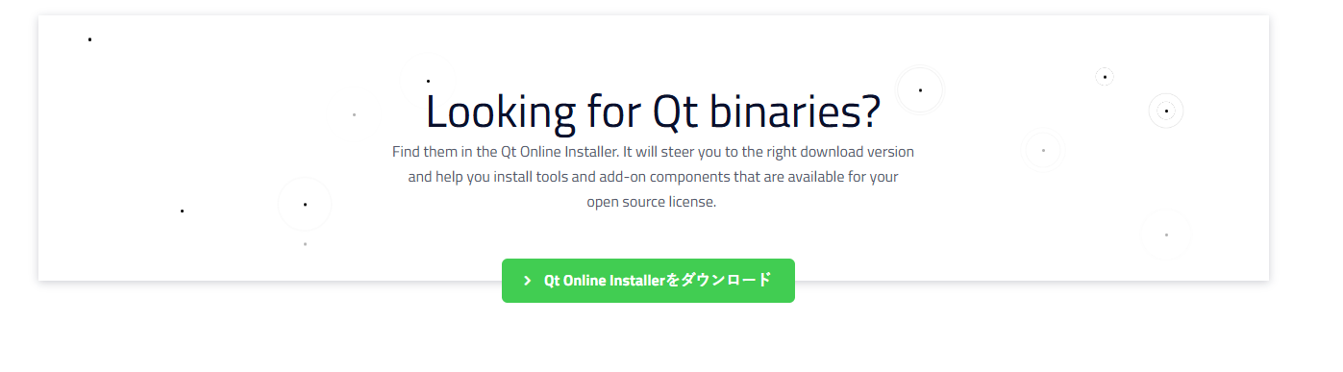

* In new page scroll down and Click on QT online installer button (above pic for reference)

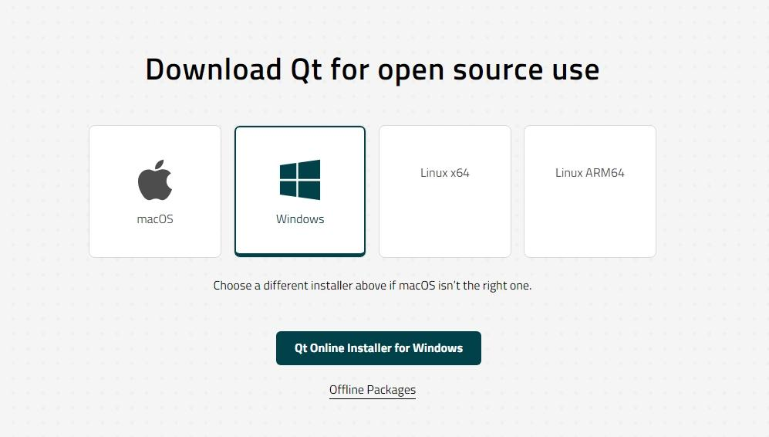

* Select windows and click on “qt online installer“ and go to folder in which installer file is downloaded (above pic for reference)
* Open terminal in folder where installer file is downloaded and run command " .\qt-online-installer-windows-x64-4.8.0.exe –mirror <http://www.nic.funet.fi/pub/mirrors/download.qt-project.org>”
* Enter your account credentials and login.

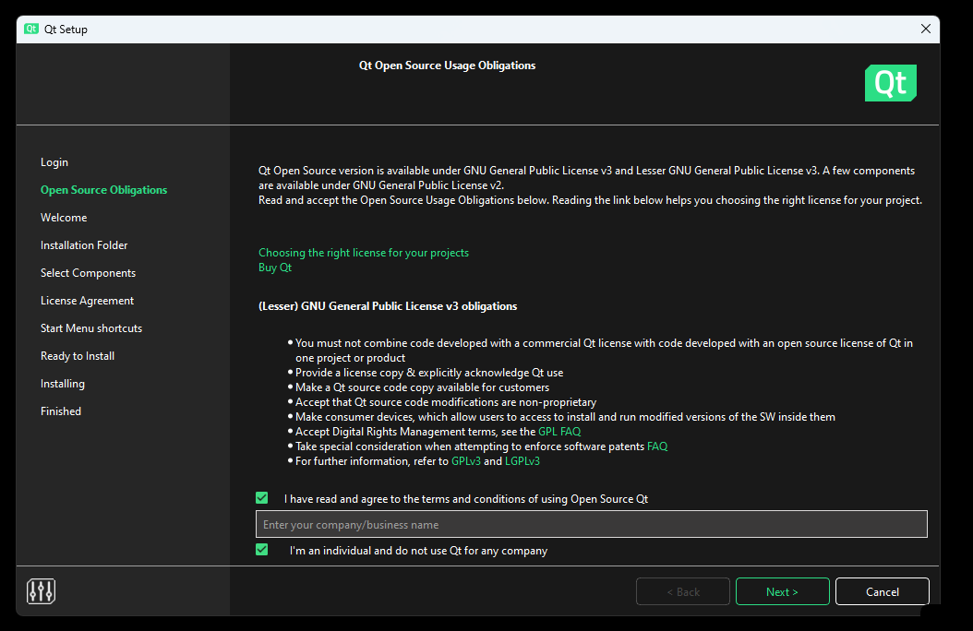

* Check both options like in above screenshot and click next
* 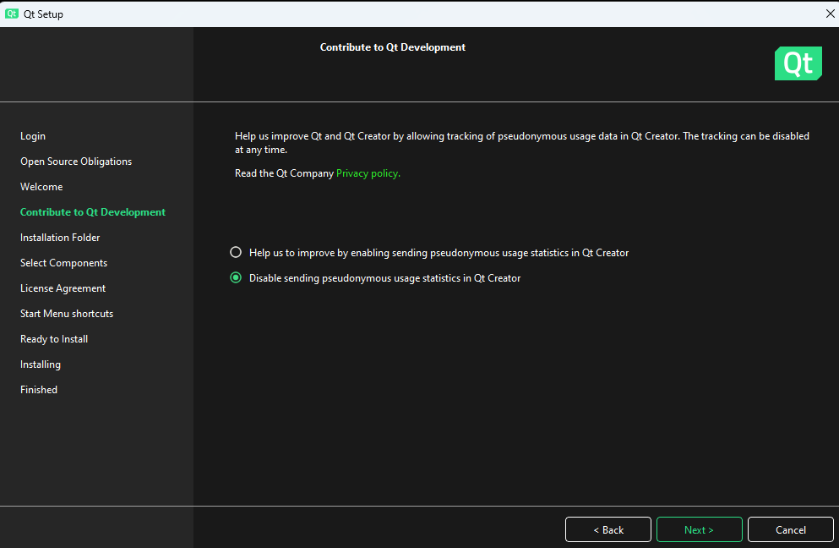
* Select option like in above screenshot and click next
* 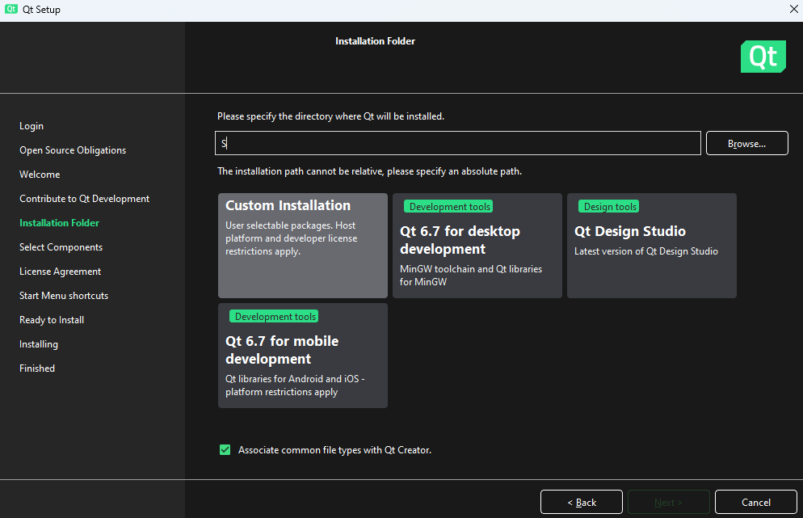
* Select custom installation and click next.
* 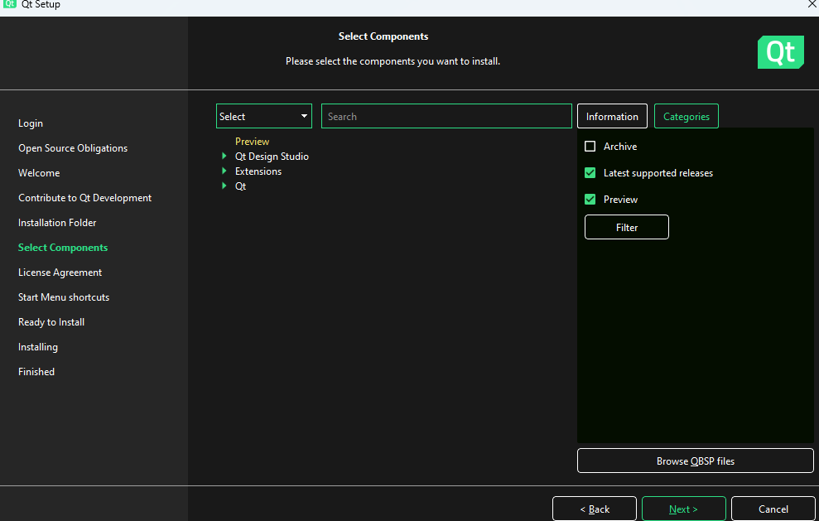
* Select Categories-> archive option on the right side and then click on “Filter”
* Now go inside QT -> select 5.15.2 -> select MSVC 2019 64 bit, android and qt charts (refer dev guide for more information <https://docs.qgroundcontrol.com/Stable_V4.4/en/qgc-dev-guide/getting_started/>)
* 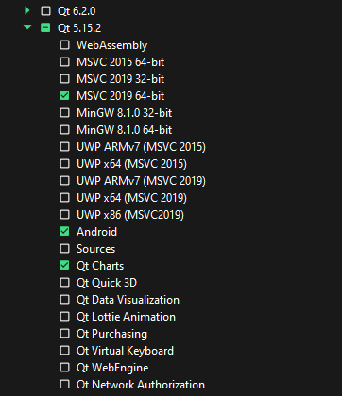
* 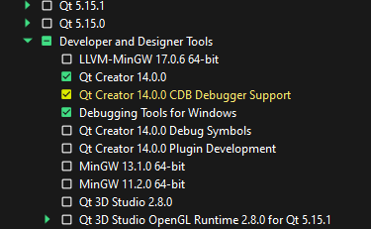
* 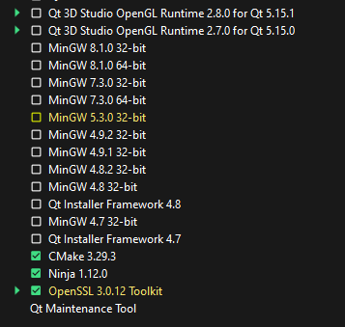
* Click next and select QT installer LGPL licence agreement . Check box and click next.
* 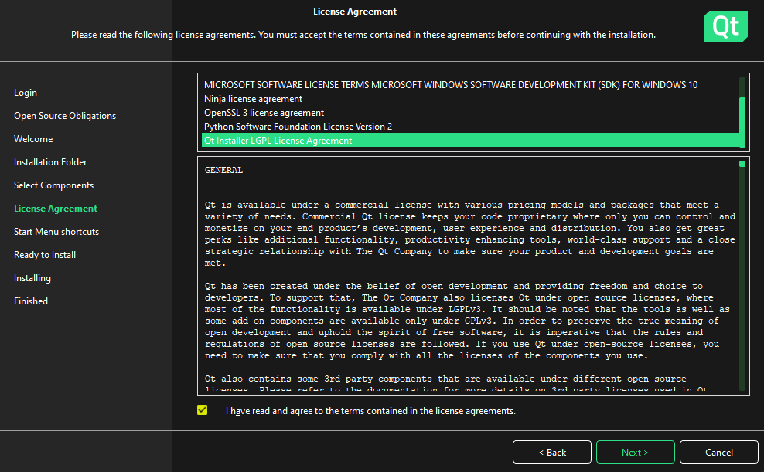
* Click next and select install

1. **Download Qgroundcontrol application.**

* Reference dev guide for qgroundcontrol application <https://docs.qgroundcontrol.com/Stable_V4.4/en/qgc-dev-guide/getting_started/>
* Open terminal in downloads folder and clone the repository using command “git clone --recursive -j8 <https://github.com/mavlink/qgroundcontrol.git>”
* After downloading go into qgroundcontrol folder using command “cd qgroundcontrol”
* Inside qgroundcontrol folder enter command “git submodule update –recursive”
* Checkout commit with tag v4.4.1 and name it latrics-dev-branch “git checkout tags/v4.4.1 -b latrics-dev-branch”
* Remove files if you face error when running above command “rm resources/SDL_GameControllerDB/LICENSE resources/SDL_GameControllerDB/README.md resources/SDL_GameControllerDB/gamecontrollerdb.txt”
* run commands to download submodules “git submodule init” and “git submodule update”.

1. **Configure Android in Qt creator**

* Download android studio
* Go to Qt academy <https://academy.qt.io/learner-dashboard>
* Select Getting started with Qt for android course and follow it to configure android
* Use jbr 17
* Use command line tools version 10 and rename it to latest if u face any issue
* In C:\Qt\5.15.2\android\src\3rdparty\gradle\gradle\wrapper gradle-wrapper.properties file change the gradle distribution to 7.3 by adding

“distributionUrl=https\://services.gradle.org/distributions/gradle-7.3-bin.zip

”

* 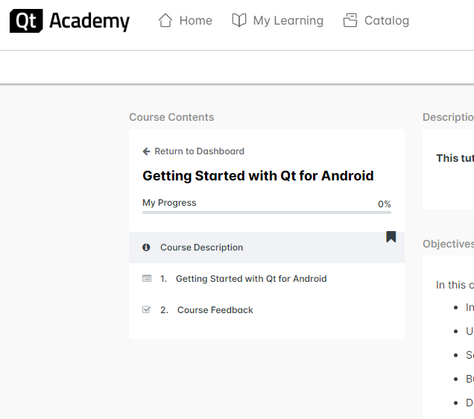

1. **Open Qgroundcontrol in Qt creator**

* Open qt creator
* Select open project option
* 
* Select qgroundcontrol folder and select qgroundcontrol pro file and press enter
* In the qgroundcontrol\android folder open manifest file and replace package name with any valid package name.
* In C\qgroundcontrol\build\Android_Qt_5_15_2_Clang_Multi_Abi-Debug create a ANDROID_PACKAGE_SOURCE_DIR directory
* Copy “C:\qgroundcontrol\android” contents in “C:\qgroundcontrol\build\Android_Qt_5_15_2_Clang_Multi_Abi-Debug\ANDROID_PACKAGE_SOURCE_DIR” directory
* Run the app
* Now go to qgroundcontrol\build\Android_Qt_5_15_2_Clang_Multi_Abi-Debug\android-build and open build file and add

classpath 'com.android.tools.build:gradle:7.0.0'